**Reverse a String**

The reversing of a string is nothing but simply substituting the last element of a string to the 1st position of the string.

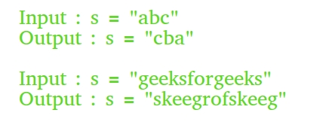C++

#include<iostream>

using namespace std;

int main()

{

string s;

cin >> s;

string newString = "";

int l = s.length() - 1;

while(l >= 0)

{

newString = newString + s[l];

l--;

}

cout << newString;

return 0;

}

**INPUT:**

**ABCD**

**OUTPUT ;**

**DCBA**

This C++ code reads in a string from the user and reverses it by creating a new string called **newString**. It then uses a while loop to iterate through the original string in reverse order, starting from the last character and going to the first. For each iteration, it appends the current character to **newString**. After the loop finishes executing, **newString** will contain the reversed string. Finally, the code prints the reversed string to the console using the **cout** function.